**Project Meeting Agenda**

**Meeting Agenda**

Date: 11/28/21

Meeting purpose: Discuss project proposal and solve our issue

Start time: 6:10 pm

Expected end time: 7:00 pm

Location: Zoom

Items to bring: laptop

Invitees:

**Topics**

General Announcements.

Review minutes of the previous meeting.

Project Status Review – Each team member participates by reporting on the following:

* Review actions items assigned at the last meeting
* Accomplishments/activities since the last review
* Plans for next period
* Issues resolved
* New issues encountered and if necessary, mitigating plans
* Other comments or concerns

**Our plan for weeks: November 28 - December 5**

***Group plan:***

* Set up more on Website = **Dylan**
* Contact David goods for a solar panel discussion = **Elina**
* Work on data analysis from WAB building = **David and Larry**
* Find measurement for the rooftop = **David**
* Contact KIPP for data = **Elina**
* Work on Project Revised = **Elina, Mbisana, Dylan**
* Work on PPT presentation = **Elina, Mbisana, Dylan**

-------------------------------------------------------------------------------------------------------------------------------

**Project Status Review**

***Dylan:*** Need to improve websites with more information. With help by a group.

Look if I find any website with data.

Contact by email to several solar panel companies.

**Result:**

Images of the updated website: ***(Not 100% complete yet)***

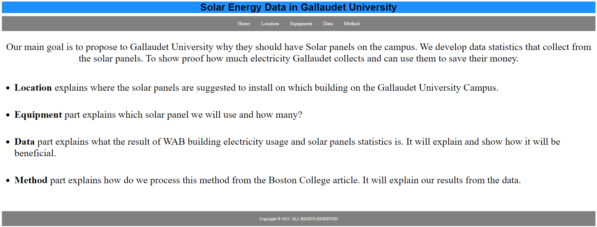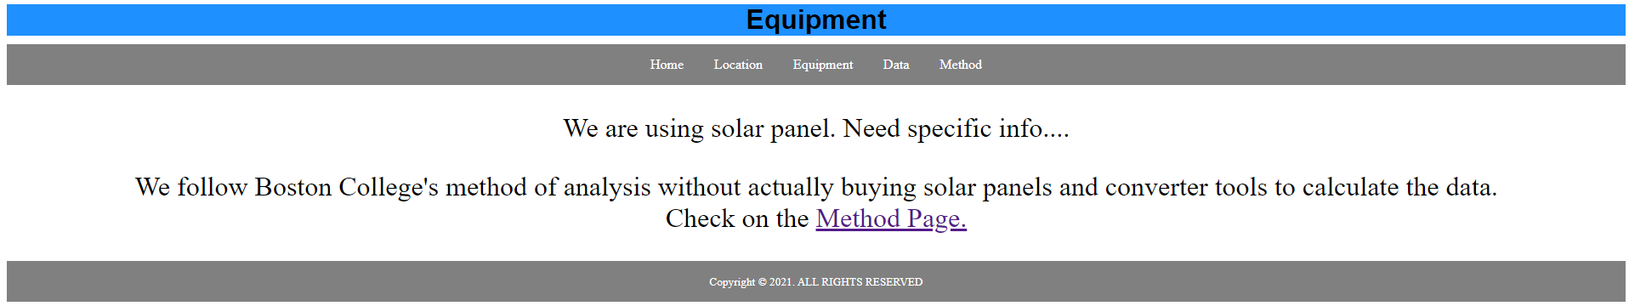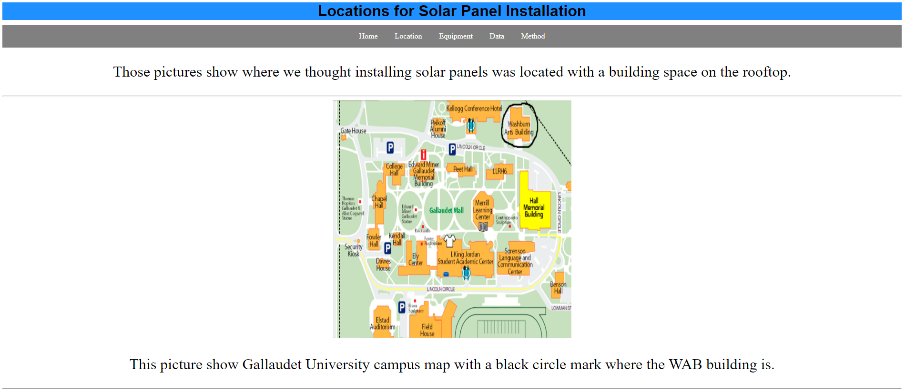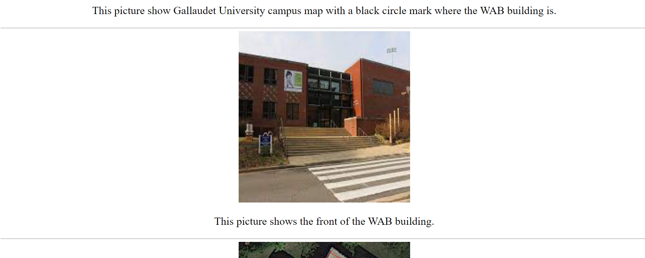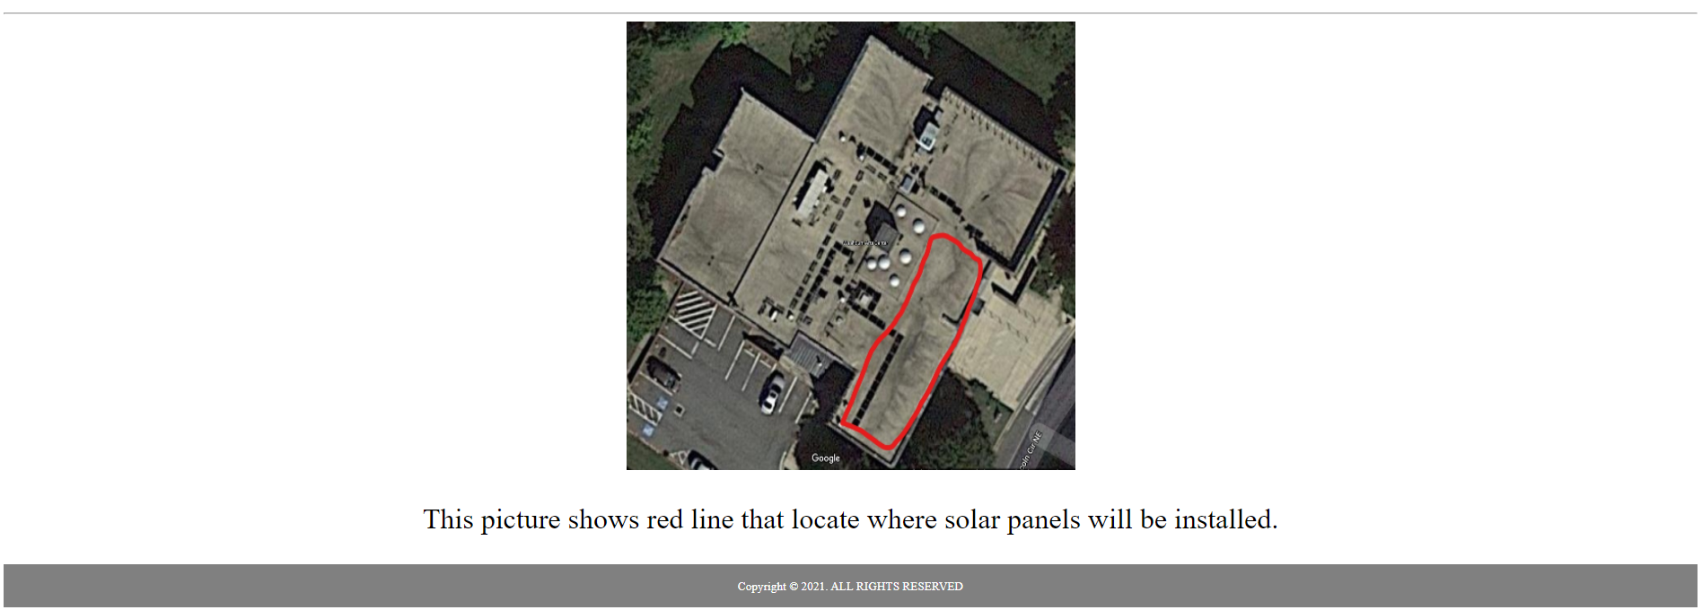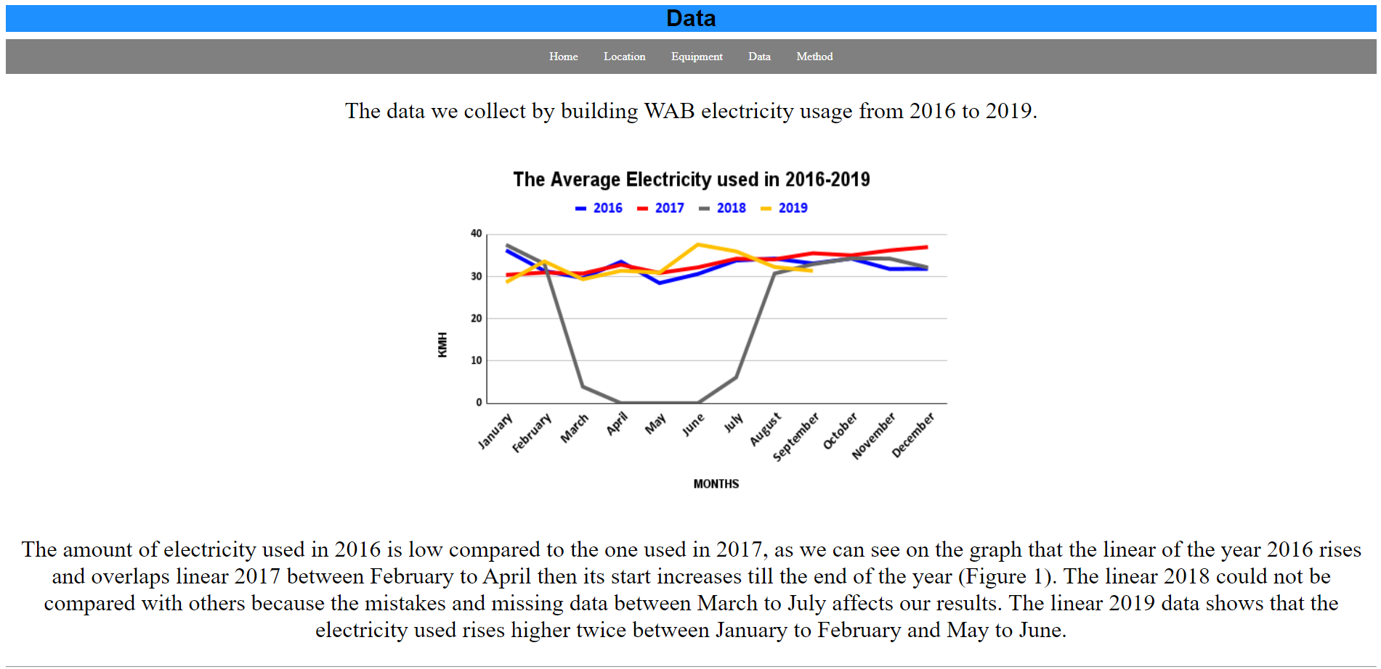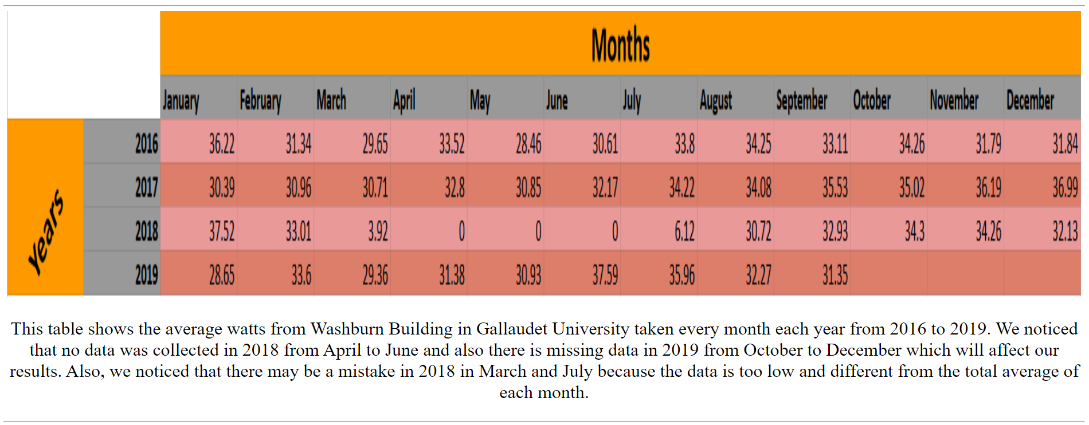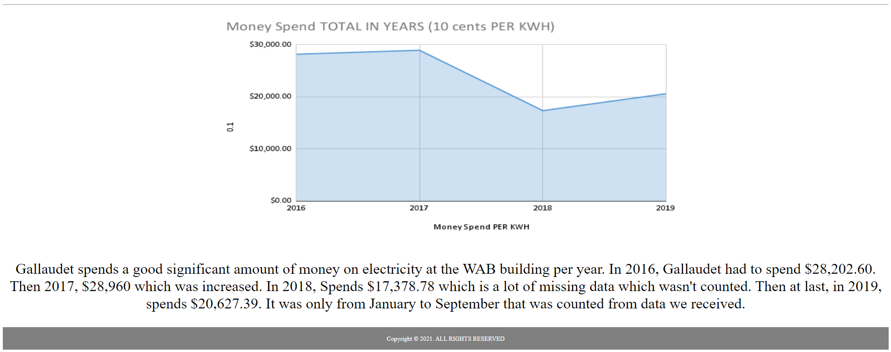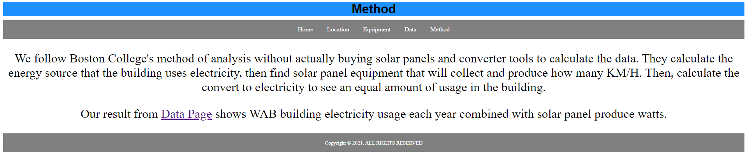

Companies:

[**https://www.nrel.gov/gis/solar-resource-maps.html**](https://www.nrel.gov/gis/solar-resource-maps.html)

Only show the results of 2018.

However, I did contact them to see if the right company would tell us the information about sunlight. Hopefully, it will actually give us data.

I did email several other solar panel companies in DMV hopefully to get an email from them to get sunlight info.

List companies:

* <https://www.ipsunsolar.com/>
* <https://standardsolar.com/>
* <https://www.celestialsolarinnovations.com/>
* Since the sunlight method dropped by discovering Boston College method isn’t use sunlight at all. I will join help David and Larry to work calculate data also work with Elina and Mbisana on project proposal and presentation.

***Elina:***

I contacted Kiran Mapes for KIPP solar panels since KIPP has a nice # or solar panels behind the building and she referred me to David Good. I emailed David Good before fall break and heard nothing back from him. Will follow up with him this monday.

Working on Project proposal and PPT with Mbsiana and Dylan

**Result:** Edited some grammars, data, our structures on Project Proposal.

Also Heard nothing back David Good.

***Larry:*** Contact to Solar energy company to ask more questions related to solar panels.

Work with David to calculate solar panels.

**Result:** waiting to find out more information from District Energy. Will follow up with them tomorrow (Monday, 11/29/2021)

***David:*** Figure out data on how many solar panels will fit on the WAB rooftop. Work with Larry to calculate solar panels.

**Result:** 24 solar panels put on the rooftop for one place of WAB.

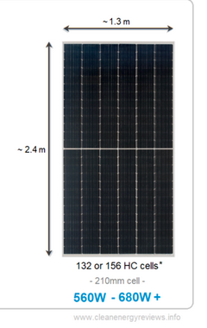24 solar panels, 132 x 24 = 3168 or 156 x 24 =3744 HC cells. Area: 1.3 m x 2.4 m = 3.12 m2 and 3.12 m2 x 24 = 74.88 m2

***Mbisana:*** Created a form survey with questions about how use of electricity power have been challenging and how would solar panel be beneficial to WAB building and share it with WAB faculty Professors.

Working on Project proposal and PPT with Elina

**Result:** only 1 responded out of 7. will follow up with them see if they can help filling the form

**Our Weeks plans:**

|  |  |  |
| --- | --- | --- |
| Week | To do List | Complete? |
| October 24 Week | * Finalize find and order tools for solar panels * Set up more on Website (Dylan) * Need gather data of electricity usage of WAB building * Need to request if they are approved to use their roof, if not, we can use their front ground to experiment. * Start on Project Proposal | * Yes and no * Yes and no * Yes * No * Yes |
| October 31 Week | * Meeting report #4 * Hopefully get tools then set up tools start the data * Finish Project Proposal (Due Nov 9) * Discuss Elevator Pitch | * Yes * No * Yes * Yes |
| November 7 Week | * Project demo 1 show how collect and my website idea * Analyze data | * No and yes * Yes |
| November 14 Week | * Conunitne analyze data * Hopefully we can find specific data that we can find to understand why we need to use our building. * Find sunlight data from company or David Good | * Yes and no |
| November 21 Week | * Fall Break * Meeting report #5 * Presentation Slides | * Yes and no |
| November 28 Week | * Finalize Website * Finalize Data of Solar Energy and profit * Revised Project Proposal | * Yes and working on it |
| December 5 Week | * Work on Final paper :) | * Work on it |

**Our new issue needs to look at:** Change plan sunlight from company to focus data on the solar panel how many products will equal to watts usage in WAB?

**Concern:** Couldn’t reach companies to get info of sunlight.